Reduce, reuse recycle

|  |  |
| --- | --- |
| **Renewable Resources** | **Non-renewable Resources** |
| Solar energy | Coal |
| Wind energy | Oil |
| Geothermal | Uranium |
| Water | Metals |
| Biomass/biofuel | Natural gas |

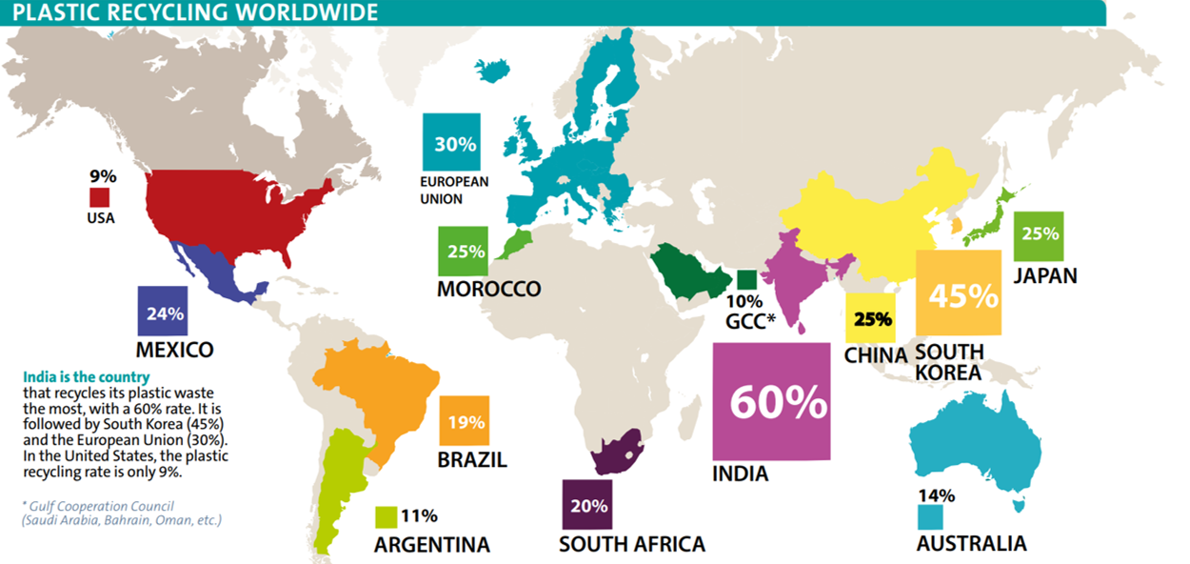

how is glass recycled

1. Glass is collected
2. Glass is separated from paper and metal
3. Glass is crushed and then sorted by colour
4. Glass chips are melted down
5. Glass is reformed using moulds into new product

How is aluminium recycled

It is collected, crushed into big compact cubes and melted down. Pure aluminium is very stable and can be recycled over and over again.

Aluminium can go back in circulation 2-3 months after being recycled.

Production of aluminium from aluminium oxide involves electrolysis and large amounts of energy. Recycling uses only 5% of the energy from using “virgin materials”.

Problems with mining copper and iron

Copper mines look bad, lots of energy needed for extraction, they are almost empty and has major environmental impacts.

From mining and transporting of raw materials  
- Air pollution  
- Noise pollution  
- Loss of land (due to mining of haematite, coke and limestone)  
  
From extraction of iron from haematite  
- Atmospheric pollution (from gases such as carbon dioxide - which contributes to the greenhouse effect; carbon monoxide, which is poisonous, and sulfur dioxide, which is also poisonous and causes acid rain)  
- Tailings (normally produced as slurry) are large amounts of waste produced by ore mills, and they are dumped into ponds which come from natural valleys.   
- Loss of land (from the building and size of chemical plant)  
- Noise pollution  
- Disposal of slag (some of the slag do not end up being used to make roads - instead, they are simply dumped)